A Sneak Peek In The Future Of Automation With Zero Latency 6G Network.

1. Abstract:

As the demand for high-speed, reliable, and low-latency communication is increasing with the evolution of technology. The emergence of 6G is a promising solution to meet the needs of the digital era. The paper presents an inclusive review of the evolution of network communication along with the challenges and opportunities of the emerging 6G technology in network communication. Moreover, this paper reviews the possible future landscape and network architecture of the sixth-generation wireless network communication. In the conclusion of this paper, there’s a holistic overview of the current status along with the future direction of 6G communicational technologies.

1. Introduction:

Between the first generation (1G) and the state-of-the-art fifth generation (5G), wireless network evolution has advanced remarkably. Three main use cases for 5G networks have been identified by the International Telecommunication Union (ITU): massive machine-type communications (MMTC), ultra-reliable and low latency communication (URLLC), and improved mobile broadband (EMBB). 5G uses technologies such as millimeter-wave (mm-Wave), multiple-input multiple-output (MIMO), and device-to-device (D2D) communication to handle a variety of service requirements. As 5G network deployment advances, future developments come into sharper focus, with attention shifting to 6G network development. The 6G networks are expected to fulfill the demands of the advanced intelligence society of 2030. They must incorporate connected intelligence with AI capability and support ultrahigh rates of data, ultralow latency, high reliability, and high energy efficiency with very high mobility, massive connectivity, and large frequency bands. The core of the currently proposed 6G network architecture is an integrated space-air-ground-undersea network (ISAGUN), which is composed of layers for space, air, ground, and underwater communication. Offering broad coverage and connectivity through airborne platforms, satellites, ground networks, and underwater communication is the aim of this concept. SDN, NFV, and network slicing are examples of current 5G infrastructures that the first 6G networks will need to leverage while managing the challenges of large-scale development and rigorous standards.

Application, control, data mining and analytics, and sensing comprise the four layers of this research paper's architecture for 6G networks. The architecture helps 6G networks in their endeavors to self-optimize, self-configure, and self-heal by means of intelligent extraction of important information from big volumes of data. We look at how AI approaches are used for mobile edge computing, and spectrum management as well as mobility and handover management apps. In order to create 6G intelligent networks with artificial intelligence, the paper finishes by highlighting important future research directions moreover, because 5G networks lay the groundwork for sophisticated communication-driven industrial change and digitization, it underscores how revolutionary these networks might be. As latency, connectivity, and data rate issues arise, 4G and 5G networks address them. Applications like high-definition streaming, augmented reality, and virtual reality now have more prospects as a result. In the sections that follow, the article presents the use of AI approaches in the context of intelligent management systems, and mobile edge computing enabled by AI. The study paper concludes by outlining the directions for future research works of 6G intelligent networks that are enabled by artificial intelligence (AI), emphasizing the pivotal role that AI will play in determining the trajectory of wireless innovation and connectivity.

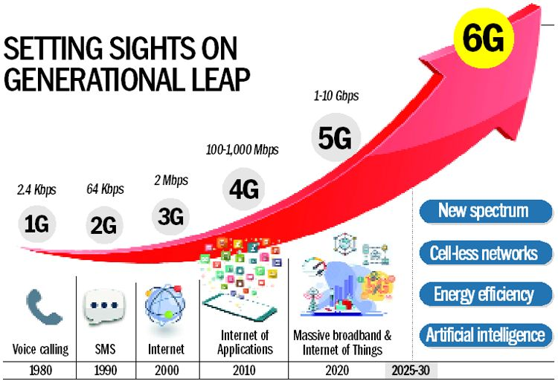

Fig.1. All Generations of network communication.

1. Challenges:

In the exploration of the potential advancements and opportunities presented by 6G technology, it is imperative to critically assess the associated challenges and obstacles that necessitate meticulous consideration for its seamless integration and successful implementation. The following key challenges have been identified:

**1. Increased Infrastructure Requirements:** The transition to 6G technology, leveraging a higher frequency spectrum than its predecessor, inherently demands a proliferation of cellular infrastructure. This proliferation poses substantial economic and logistical challenges, as the deployment of a multitude of cell phone towers becomes both economically onerous and impractical within the confines of existing technological frameworks.

**2. Connectivity and Range Limitations:** Persistent issues related to connectivity and limited range, prevalent in the current 5G landscape, may persist with the advent of 6G technology. The susceptibility to connection failures in the presence of obstacles and the limited spatial reach of the network poses formidable challenges. The higher frequency radio waves employed by 6G may exacerbate these concerns, necessitating innovative solutions to ensure robust connectivity across diverse environments.

**3. Interference Challenges:** The utilization of significantly higher frequency bands in 6G introduces the potential for interference with other devices operating within the same frequency spectrum. Mitigating interference issues is imperative to maintain the integrity and reliability of 6G networks, necessitating advanced spectrum management strategies.

**4. Radiation Standards and Health Implications:** The heightened frequency waves characteristic of 6G technology raise legitimate concerns regarding radiation standards and potential health implications. Rigorous assessment and adherence to established safety standards are paramount to address apprehensions surrounding radiation poisoning among various organisms, ensuring the responsible deployment of 6G infrastructure.

**5. Elevated Energy Consumption and Thermal Management:** The adoption of higher frequency bands in 6G technology brings forth a notable increase in energy consumption during both the transmission and reception of radio waves. Effectively managing this heightened energy demand is essential to avoid adverse environmental impacts and to ensure the sustainability of 6G networks. Additionally, the need for enhanced thermal protection mechanisms in 6G devices is imperative to mitigate the elevated heat generation associated with these higher-frequency operations. Thus, this could in turn lead to a rise in Global surge in Carbon footprints and may be damaging to the environment.

1. Evolution Of Mobile Wireless Communication Network:

As technology progresses every year and introduces something new to the world. Mobile Wireless Communication Networks (MWCN) have also come a long way in development since the first generation of the mobile network was greeted in the 1980s. The five distinct mobile network generations that we have at present are 1G, 2G, 3G, 4G, and 5G where “G” represents the version or generation of the mobile network. The first generation (1G) of mobile networks was the base of the evolution of mobile networks and it was simply introduced for voice calls as the mobile phones of that era were not developed as of now. Talking about the second generation (2G) of wireless mobile networks, it was the developed version of the previous one and this was the generation when digital phones were introduced to the world. Short Message Service (SMS), Multi-media Messaging Service (MMS), International roaming, and other features were offered in the second iteration of mobile networks. The Third Iteration (3G) of mobile communication offered services like video calls, mobile TV, location-based services, and many more. At that time, mobile phones were widely accessible to people, and connectivity in the world increased. The key goal of 3G was to enhance the rate of information transmission and offer the capability to serve a variety of applications. Afterward, the Fourth generation came into the business, and from 2010 to now it has been the most widely used mobile network. 4G offers the Long Term Evaluation (LTE) also known as 4G LTE which is a standard for wireless data transmission. Currently, we have the fifth generation of mobile network (5G) which came in 2020 and offers a higher rate of data than all the previous generations of MWCN. Let's discuss the evolution of mobile communication networks in actual detail (generation by generation):

### 4.1. From 1G to 2G:

1 December 1979 was the day when the first-generation (1G) mobile network was greeted by Nippon Telegraph and Telephone (NTT) in Tokyo, Japan. The rate of data offered by 1G was up to 2.4 kbps and a frequency of 800 MHz, it was deployed to provide analog cellular service which allows users to make voice calls, The first generation of mobile networks was designed to work on a technique called FDMA (Frequency Division Multiple Access). As it was the base of all the generations of mobile networks, 1G had many drawbacks like low transmission efficiency, no security, poor voice quality, etc. In 1991, the mobile networks revolution kicked off in Finland as second-generation (2G) mobile networks were unleashed by Radiolinja (now part of Elisa Oyj), setting the stage for a new era on the GSM (Global System for Mobile Communications) standard. Fulfilling the drawbacks, 2G surpassed its predecessor, 1G, by offering clearer calls, and efficient data transfer, and gave birth to Short Message Service (SMS). 2G also introduced international roaming and provided high better network coverage than 1G. 2G used to operate on both the 900 MHz and 1800 MHz frequency bands with a data rate of up to 64Kbps. 64Kbps and the top speed of a second-generation mobile network is 50Kbps with General Packet Radio Service (GPRS) or 1Mbps with Enhanced Data rates for GSM Evolution i.e. EDGE.

### 4.2. From 3G to 4G:

The dawn of the third iteration or generation of mobile communication networks arrived in the early 2000s, with the debut of 3G ushering in a new era of high data speeds and expanded capabilities for mobile communication. 3rd Generation Partnership Project (3GPP), an association that was formed to help with the deployment of the 3G network. 3GPP proceeded with a framework that satisfies an IMT2000 (International Mobile Telecommunications). 3GPP was established to improve overall performance for mobile communication. The vision of 3GPP was to improve globally applicable specifications for 3G to provide high-quality multimedia service, and high data rates and to completely replace the current method of conducting phone calls with Voice-Over-IP (VOIP). 3G operates at a range of 2100 MHz frequency band. 3G opened the door for users to access advanced services such as mobile TV, and broadband and expanded the range of possibilities beyond voice calls and text messaging services. The Initial Introduction of the fourth generation of mobile networks was marked by TeliaSonera in December 2009 in Sweden. With the improved network capabilities compared to its predecessors, 4G came with a high download speed of 100 Mbps to 1 Gbps as well as an upload speed of 50 Mbps. Long Term Evaluation (LTE), also known as 4G LTE, is a standard for wireless data transmission created by the 3GPP with an average speed between 50-250 Mbps, much faster than the third-generation. Wireless Interoperability for Microwave Access (WiMAX) is also considered a 4G standard. The fourth generation is not just a speed booster but also a digital maestro conducting a symphony of voice and data, all wrapped up in the all-IP (Internet Protocol) standard. 4G is like going from sending postcards to streaming 4K videos, a great tech revolution. Since its beginning, 4G has been widely adopted globally as it offers many services like seamless connectivity, enjoying favorite shows or movies on mobile phones without annoying buffering pauses, high-quality video calls, etc. Fourth Generation enables terminal mobility to offer wireless services at any time and anywhere on your instant wish, it is not just a network; it’s a gateway to a digital wonderland where we have high-speed data along with high-quality voice and video calls and seamless connectivity all over the world.

### 4.3 Fifth Generation (5G):

Introducing you to the era of 5G, launched in 2020, emerges as the paragon of connectivity, 5G is not just promising an incremental improvement but also a convulsion in the way we experience the digital realm. 5G has many benefits which include extremely low latency, larger connection density, and faster data speed than its predecessor. 5G offers the experience of data speeds that defy the limits of conventional connectivity. 5G is creating an environment where gaming, augmented reality (AR), and critical applications flourish seamlessly. 5G is a game changer for IoT (Internet of Things) as well as it supports a massive number of simultaneous connections per unit area. 5G network technology can even create a modern society using virtual reality technologies. Along with the use of the recently assigned spectrum of the microwave band (3.3-4.2 GHz), 5G also provides greatly increasing data rates which is up to 10 Gbps, for the first time by innovatively using the millimeter-wave band. The major 5G usage scenarios that were proposed by International Mobile Telecommunications 2020 were Enhanced Mobile Broad-Band (EMBB), Ultra-Reliable and Low Latency Communications (URLLC), and Massive Machine Type Communication (MMTC). Nearly 200 times faster than the 4G network, In ideal conditions, 5G has the ability to deliver speeds up to 20 Gbps and average data rates of over 100 Mbps. In essence, 5G opens up a world of exciting possibilities, this means we connect quicker, talk clearer and we can even work together in ways we never thought possible. 5G is giving our digital world a turbo boost, which makes everything smoother and more efficient.

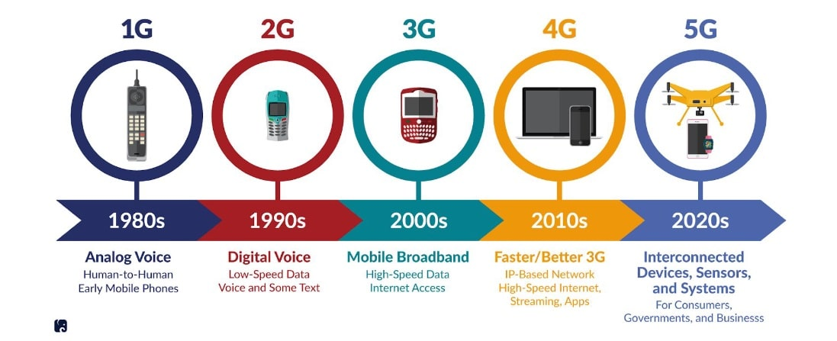

Fig.2. Evolution of network communication from 1G to 5g.

## Network Architecture And Future Scope:

As of now, 6G technology is under development, and still in the conceptual and early stages, so no such standardized network architecture has been universally agreed upon. But according to the collected information by our research we can just provide an overview or some insights based on the trends and considerations in the evolution of network communication:

* **Artificial Intelligence (AI) Integration:** Artificial Intelligence And Machine Learning are expected to have a pivotal role in various tasks in the sixth generation of mobile networks. Tasks like network optimization, resource allocation, and interference management will be done by the massive influence of AI/ML. Many other tasks of intelligence interaction between humans and things will be improved, as of now the existing interaction method

are mostly passive relying methods, For example, if technologies such as VR and robotics are used in manufacturing or agricultural production, then human hands will be free of load in the 6G era.

* **Terahertz (THz) Communication:** Higher than currently used technologies, 6G is expected to provide frequency in the terahertz range. With the band of 0.1-10THz, THz communication has higher spectrum resources up to hundreds of giga-hertz than those are in currently used with the mm-wave band (24.25 to 52.6 GHz). So THz communication can easily achieve multi-Tb/s data transmission.
* **Satellite Communication Integration:** In the sixth generation of network communication, it is expected to have a significant role of “Satellite Communication Integration” in achieving high-speed global connectivity, providing coverage in underserved areas. There will be seamless support mobility for users across different environments. There will be prioritized energy-efficient satellite designs to reduce operational costs and environmental impact.
* **Security and privacy enhancement:** To protect the confidentiality of data, 6G will implement a robust encryption mechanism. The data that is shared from the sender’s end to the recipient will be end-to-end encrypted. Mutual authentication and certificate-based authentication are some of the strong authentication mechanisms, that will be deployed to verify the identities of users, devices, and network entities.
* **Cloud Computing:** In the sixth generation of network communication, cloud computing extends to the network edge. The platforms with edge computing will host applications and services closer to end-users and IoT devices. Network slicing will be enabled which will allow multiple virtual networks to coexist together. There will be scalability and elasticity in cloud computing which will allow 6G networking to dynamically scale resources up or down according to the demand. The security and privacy concerns will be addressed to protect sensitive data and to preserve user trust.
* **SDN:** Software-defined networking (SDN) in 6G network will provide a programmable interface that enables programmability and automation. SDN will provide the facility of dynamic network slicing in 6G network which will allow the creation of isolated and customizable network slices to diverse use cases. SDN will contribute to sustainable and green networking in 6G by minimizing energy consumption and optimizing resource utilization.

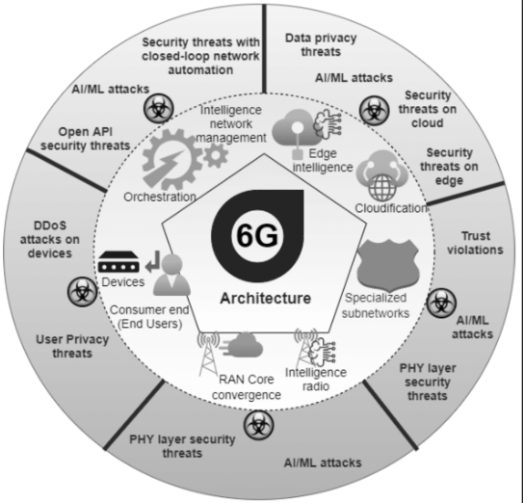

Fig.3. Network Architecture of 6G mobile communication.

## Conclusion:

The rapid increase in demand for high-speed data, low-latency communication, and reliability has led to the rise of 6G network communication. The emergence of 6G marks a pivotal moment in technological advancement, and it is the need of the future of the digital era. The paper highlights the future scope of the 6G network communication along with the challenges of setting up the 6G networking. It also discusses briefly the evolution of mobile wireless communication networks one by one from 1G to 5G. The paper answers how the upcoming 6G networking will be different from its predecessors. Artificial Intelligence And Machine Learning, Cloud Computing, and many other technologies will play a lead role in the emerging sixth iteration of mobile wireless communication for performing various tasks like network optimization and many more that were already discussed in the network architecture of 6G. For future research works, it may serve as an enlightening review of 6G mobile communication.

## Literature Cited:

[1].Tongyi Huang, Wu Yang, Jun Wu, Jin Ma, Xiaofei Zhang, and Daoyin Zhang, "A Survey on Green 6G Network: Architecture and Technologies”, IEEE Access, vol.7, December 2019.

[2].Taras Maksymyuk, Juraj Gazda, Marcel Vološin, Gabriel Bugár, Denis Horváth, Mykhailo Klymash, and Mischa Dohler, "Blockchain-Empowered Framework for

Decentralized Network Management in 6G", IEEE Communications Magazine, vol.58, issue:9, September 2020.

[3].Helin Yang, Arokiaswami Alphones, Zehui Xiong, Dusit Niyato, Jun Zhao, Kaishun Wu," Artificial-Intelligence-Enabled Intelligent 6G Networks.", IEEE Network, vol.34, issue:6, November/December 2020.

[4].Guangyi Liu, Yuhong Huang, Na Li, Jing Dong, Jing Jin, Qixing Wang, Nan Li," Vision, requirements and network architecture of 6G mobile network beyond 2030.", China Communications, vol.17, issue:9, September 2020.

[5].Xuemin Shen, Jie Gao, Wen Wu, Mushu Li, Conghao Zhou, Weihua Zhuang," Holistic Network Virtualization and Pervasive Network Intelligence for 6G.", IEEE Communications Surveys & Tutorials, vol.24, issue:1, Firstquarter 2022.

[6].Harish Viswanathan, Preben E. Mogensen," Communications in the 6G Era.", IEEE Access, vol.8, March 2020.

[7].Zhengquan Zhang, Yue Xiao, Zheng Ma, Ming Xiao, Zhiguo Ding, Xianfu Lei, George K. Karagiannidis," 6G Wireless Networks: Vision, Requirements, Architecture, and Key Technologies.", IEEE Vehicular Technology Magazine, vol.14, issue: 3, September 2019.

[8].M. Mahdi Azari, Sourabh Solanki, Symeon Chatzinotas, Oltjon Kodheli, Hazem Sallouha, Achiel Colpaert, Jesus Fabian Mendoza Montoya, Sofie Pollin, Alireza Haqiqatnejad, Arsham Mostaani, Eva Lagunas, Bjorn Ottersten," Evolution of Non-Terrestrial Networks From 5G to 6G: A Survey. ", IEEE Communications Surveys & Tutorials, vol: 24, issue: 4, August 2022.

[9].Volker Ziegler, Harish Viswanathan, Hannu Flinck, Marco Hoffmann, Vilho Räisänen, Kimmo Hätönen," 6G Architecture to Connect the Worlds.", IEEE Access, vol.8, September 2020.

[10].Nguyen Thi Mai Lan," Evolution of Wireless Technology: From 1G to 5G.", Asian Journal of Applied Science and Technology (AJAST), vol.7, issue:4, October-December 2023.

[11].Wen Wu, Conghao Zhou, Mushu Li, Huaqing Wu, Haibo Zhou; Ning Zhang, Xuemin Sherman Shen," AI-Native Network Slicing for 6G Networks.", IEEE Wireless Communications, vol.29, issue:1, February 2022.

[12].Anutusha Dogra, Rakesh Kumar Jha, Shubha Jain," A Survey on Beyond 5G Network With the Advent of 6G: Architecture and Emerging Technologies.", IEEE Access, vol.9, October 2020.